David McCorvey  Communications and Marketing Specialist  910 15th Street Northwest, Washington, DC, 20005 | (859) 537-5254  dwmccorvey@gmail.com | 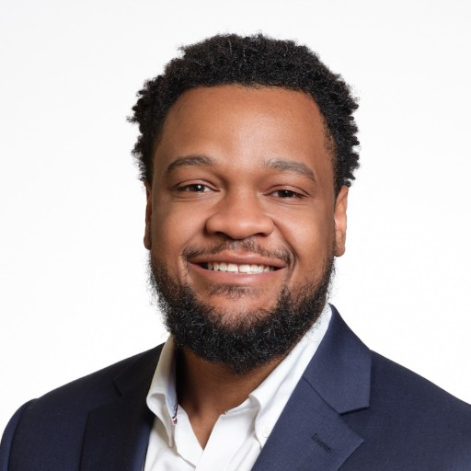

Professional summary
Dynamic Communications and Marketing Specialist, adept in strategic communication and innovative marketing solutions. Excels in crafting compelling content and executing effective campaigns to enhance brand visibility and engagement. Committed to leveraging digital analytics and creative strategies to drive business objectives and stakeholder value. Fluent in and minored in Spanish.

Employment history

So Others Might Eat (SOME) | Communications and Marketing Manager | Washington, DC
Feb 2023 - Present
- Streamlined email outreach, improving open rate by 60%
- Orchestrated photo/video shoots, enhancing client-provider connection
- Forged media relations, driving event promotion and engagement
- Redesigned website, optimizing UX/UI and content
- Maintained highest nonprofit accreditations, ensuring industry respect
- Pioneered innovative donor management strategies, strengthening funding and support.
- Boosted social media engagement by 40%, expanding audience reach.
- Implemented AI-driven analytics to track marketing ROI, enhancing strategy precision.
- Developed a multi-platform content strategy, increasing brand visibility.
- Overhauled CRM system, improving data accuracy and usability.
- Conducted market research that influenced new campaign directions.
- Expanded network of local community based organizations, donors, and partners in DC area.

Kentucky Entertainment Television - PBS | Marketing Intern
Apr 2018 - Jul 2018
- Spearheaded marketing strategies, enhancing brand visibility
- Boosted leads by 30% via innovative communication tactics
- Utilized analytical skills to evaluate campaign performance
- Resolved marketing issues, optimizing ROI by 20%
- Influenced business growth through strategic marketing

Fayette County Board of Education | Communications Intern | Lexington, KY
May 2018 - Present
- Spearheaded innovative marketing strategies
- Boosted brand visibility by 30%
- Utilized analytical skills to assess market trends
- Resolved communication bottlenecks, enhancing efficiency

WKYT News – CBS Affiliate | Broadcast News Intern
May 2018 - Aug 2018
- Led strategic marketing initiatives
- Increased brand visibility by 30%
- Developed effective communication plans
- Resolved internal communication bottlenecks

SOME | Communications and Marketing Assistant
Jun 2019 - Jun 2020

SOME | Communications and Marketing Associate
Jun 2020 - Jun 2021

SOME | Communications and Marketing Coordinator
Jun 2022 - Feb 2023

Education

Asbury University, Wilmore, KY | Bachelor of Art in Communications, minor in Spanish
May 2019 - May 2019

Georgetown University, Washington, DC | Masters in Public Relations/Corporate Communications
2019 - Jun 2023

Skills
Communication | Public Relations
Corporate Communications | Television
News | Spanish

Additional information

Honors and Leadership
• Current Racial Equity Steering Committee Member
• Managed $50,000+ Advertising Campaign at Asbury in 2018.
• Written over 350 news stories for SOME’s blog.
• Advertising manager of The Collegian, student ran news publication on campus.
• Founding member of public relations student society of America - Asbury chapter.
• Asbury Men's basketball team captain.
• Promotion from Comms/Marketing Assistant to Manager.
• WACW online radio host – The Sports Attic weekly university wide broadcast.

